# First Bytes 2014 - R Technology

### This is how my RStudio is configured:

sessionInfo()

## R version 3.0.2 (2013-09-25)  
## Platform: x86_64-apple-darwin10.8.0 (64-bit)  
##   
## locale:  
## [1] en_US.UTF-8/en_US.UTF-8/en_US.UTF-8/C/en_US.UTF-8/en_US.UTF-8  
##   
## attached base packages:  
## [1] stats graphics grDevices utils datasets methods base   
##   
## loaded via a namespace (and not attached):  
## [1] digest_0.6.4 evaluate_0.5.5 formatR_0.10 htmltools_0.2.4   
## [5] knitr_1.6 rmarkdown_0.2.49 stringr_0.6.2 tools_3.0.2   
## [9] yaml_2.1.13

You also need to install LateX if you want to generate PDF files from KnitR.



### Getting Started - Clone Repository:

**Phils-MacBook-Pro:Mine pcannata$ pwd**  
/Users/pcannata/Mine  
**Phils-MacBook-Pro:Mine pcannata$ git clone** [**https://github.com/pcannata/FirstBytesRepo.git**](https://github.com/pcannata/FirstBytesRepo.git)  
Cloning into 'FirstBytesRepo'...  
remote: Counting objects: 19, done.  
remote: Compressing objects: 100% (12/12), done.  
remote: Total 19 (delta 3), reused 19 (delta 3)  
Unpacking objects: 100% (19/19), done.  
Checking connectivity... done

### Getting Started - Creating a New RStudio Project:

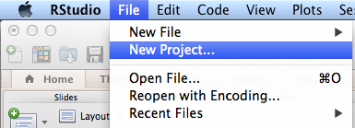

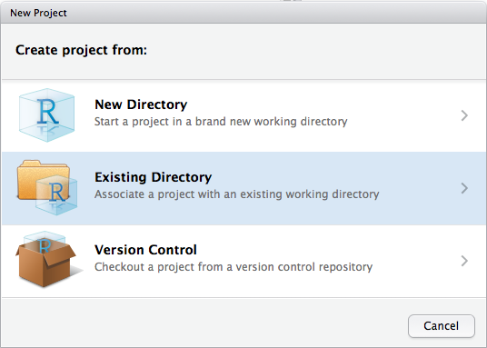

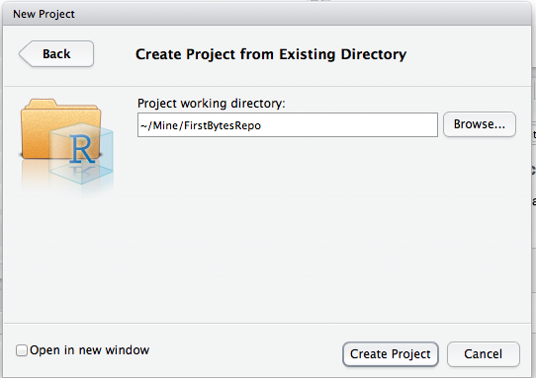

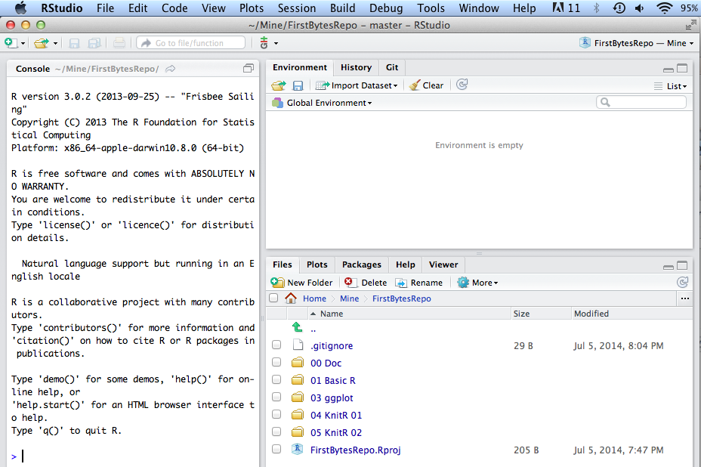

### Basic R Language Constructs

source("../01 Basic R/Basic.R", echo = TRUE)

##   
## > sessionInfo()  
## R version 3.0.2 (2013-09-25)  
## Platform: x86_64-apple-darwin10.8.0 (64-bit)  
##   
## locale:  
## [1] en_US.UTF-8/en_US.UTF-8/en_US.UTF-8/C/en_US.UTF-8/en_US.UTF-8  
##   
## attached base packages:  
## [1] stats graphics grDevices utils datasets methods base   
##   
## loaded via a namespace (and not attached):  
## [1] digest_0.6.4 evaluate_0.5.5 formatR_0.10 htmltools_0.2.4   
## [5] knitr_1.6 rmarkdown_0.2.49 stringr_0.6.2 tools_3.0.2   
## [9] yaml_2.1.13